**Solving Simple Problems in C**

**LAB #2**

**SECTION #3**

**James Gaul**

**Submission Date: 2/7/24**

**Lab Date: 2/2/24**

# Problem 1: Creating Your Own Program

Output: Image 1

# Problem 2: A Simple Program with Input

2d Rectangle Output: Image 2

3d Rectangle Output: Image 3

# Problem 3: Mysterious Output

The initial output (image 4) contained errors in each of its printf commands. The errors of each command are as follows:

1. The printf command used %lf (long format) but attempted to display a decimal value. Instead, %d needed to be used.
2. While the printf command used the correct indicator, it failed to include the variable itself.
3. This problem was an inverse of the first error, with %lf being used instead of %d when the variable in question was a double (long format) value.

The altered code (image 5) contains comments mentioning the alterations made, providing a corrected output (image 6)

# Problem 4: Simple Arithmetic

1. Int/Double Arithmetic
   1. Normal arithmetic result
   2. Normal arithmetic result
   3. Order of operations is ignored, with addition performed before division.
   4. Normal arithmetic result, rounded to 6 decimal places.
   5. Integer math is used, so fractions are dropped. Thus, 22/3 is calculated to be seven.
   6. Int calculations again result in fractions being dropped, so that 22/9 is found to be 2.
   7. As the components are all integers, fractions are dropped. Thus, 22/9 is found to be 2
   8. As the components are integers, 22/3 is found to be 7. Thus, 7 * 3 is calculated as 21
   9. As in case h, 22/3 is found to be 7. Thus, 7*3 is calculated to be 21.
   10. The parenthesis results in 22.0 / 9. However, the integer value means that the fraction is dropped, returning a value of 2.
   11. Normal arithmetic result.
2. 1. To find area from circumference, I divided the circumference by pi, then multiplied it by .5 to get the radius as a double. Then, I used the standard A = pi*r^2 formula to calculate area (again as a double).
   2. To obtain the length in meters from a length in feet, I multiplied the integer value of feet by .3048, saving the result as a double.
   3. To convert Fahrenheit to Celsius, I first subtracted 32.0, then multiplied the result by 1.8

# Problem 5: Pythagorean Theorem

For clarity in my code (Image 8) I split the calculation into four separate components with corresponding variables. The side lengths a and b were squared, then these values were added together and assigned to variable sumOfSquares. This variable was then put into the sqrt function, providing the result (Image 9).

# Screen Shots

Image 1: Problem 1 output

Image 2: Problem 2 output, 2d rectangleA screenshot of a computer

Description automatically generated

Image 3: Problem 2 output: 3d rectangle

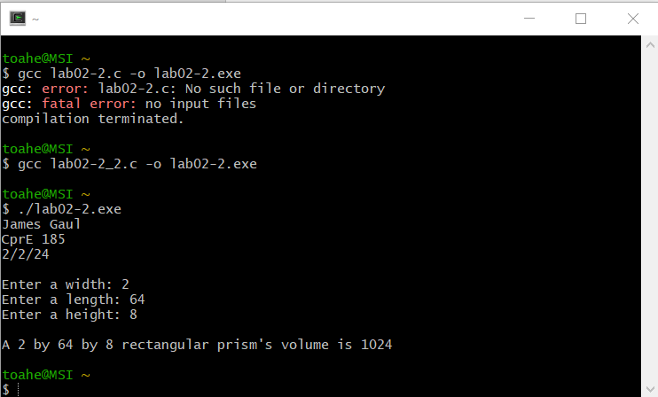

Image 4: Problem 3 (bugged) outputA computer screen shot of a black screen

Description automatically generated

Image 5: Problem 3 code:A screenshot of a computer program

Description automatically generated

Image 6: Problem 3 (fixed) output:A computer screen shot of a black screen

Description automatically generated

Image 7: Problem 4 Output:A screenshot of a computer

Description automatically generated

Image 8: Problem 5 code

Image 9: Problem 5 output

